**HYDRAULIC PROGRAM OF RUHENGERI DIOCESE IN PERSPECTIVE OF YOUTH PROMOTION**

The Hydraulic Program (PH) of Ruhengeri Diocese is one of Ruhengeri Diocese’ programs aiming integrative human development by supplying sufficient water, promoting hygiene and sanitation in population in Ruhengeri diocese and beyond, as well environmental protection. It operates since 2007 and it cooperates with various foreign and local organizations. In so doing, Hydraulic Program support Rwandan Government’s efforts in tackling the Rwandan population’s needs, specifically poor people living in remote areas. Within 20 years Pastoral Strategic Plan (2015-2035), realizations of Hydraulic Program appear in the fourth pillar, that focusing on human development.

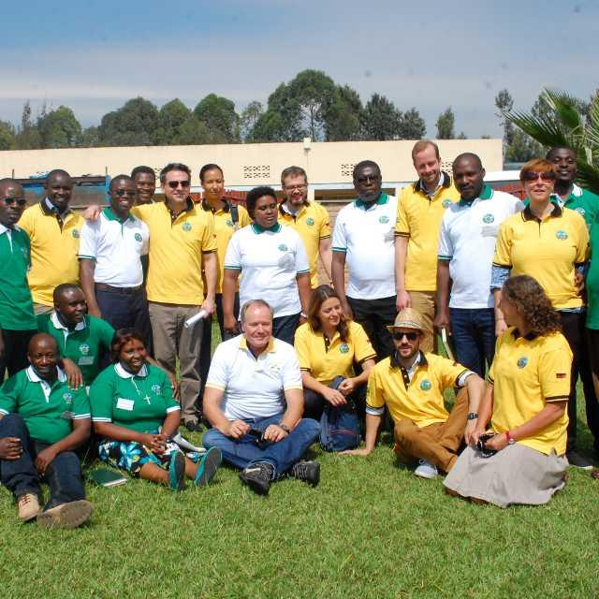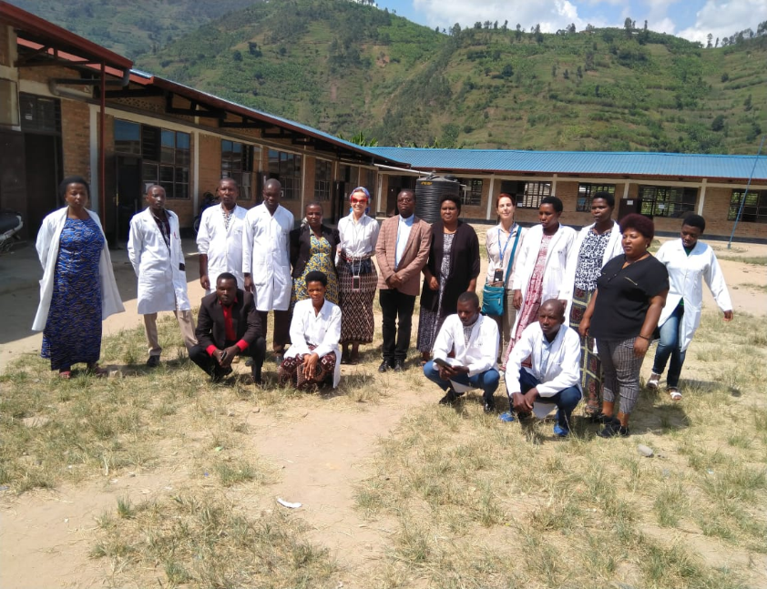

***PH staff and representatives of its partners***

**PILLARS AND MAIN ACTIVITIES FOSTERING YOUTH PARTICIPATION AND INCLUSIVENESS**

1. **Human capacity building:** This domain emphasizes youth capacity building through awareness rising by mobilization in workshops, trainings and meetings on water, hygiene, sanitation and general environmental issues

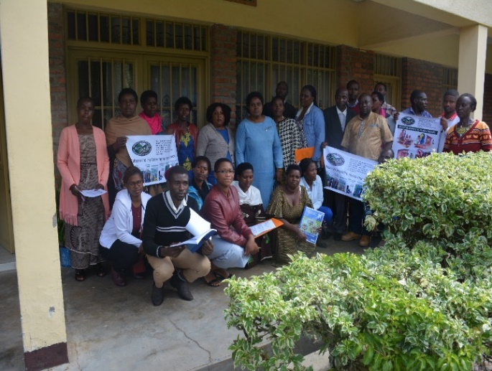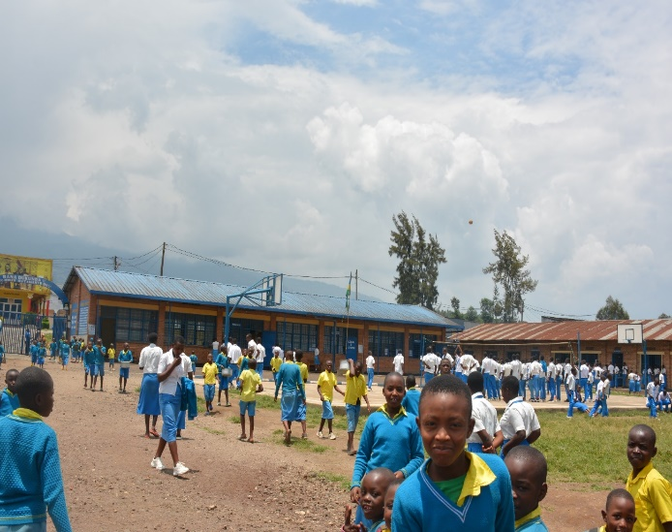

*Photos taken after training of youth on promotion of hygiene and sanitation at schools and beyond*

1. **Water supply:** The large number and growing youth population in rural areas present an opportunity for Hydraulic Program of hiring local, motivated and competent workforce in activities of water extraction, water collection, water treatment and water distribution among water users.

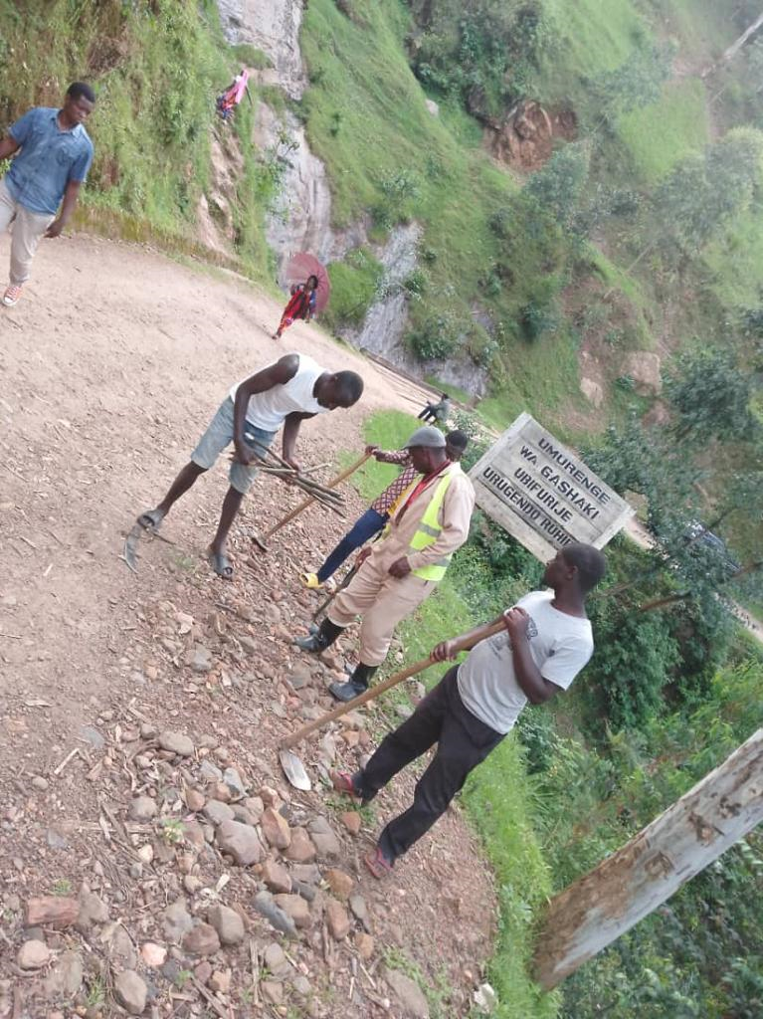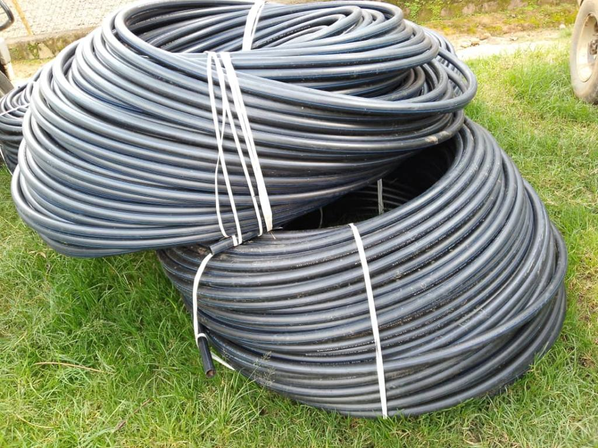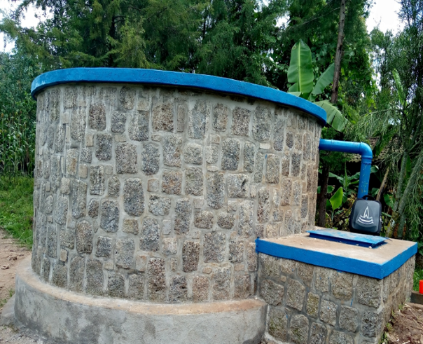

*Youth contribution in activities of construction of Water Supply System by PH*

1. **Promotion of hygiene and sanitation:** To support Rwandan Government’s initiative aiming to “reduce the national diseases burden through Community-Based-Hygiene Behavior Change and Improved Sanitation”; implemented since 2009, Hydraulic Program acknowledges the participation and contribution of youth in Clubs of Hygiene and Sanitation. Youth provides valuable contribution in construction of toilets and bathrooms in principle undertaken called “*Assainissement Total Piloté par la Communité”(ATPC)*. In addition, under sponsors from Hydraulic Program and its sponsors, youth develops different initiatives aiming at youth socio-economic developments, including small business of hygienic products.

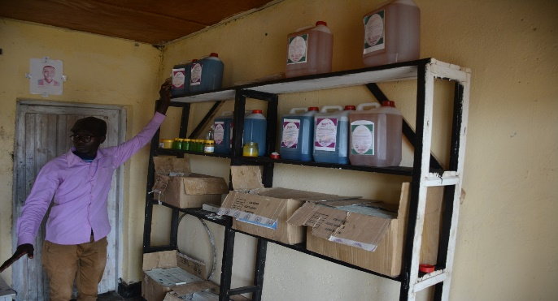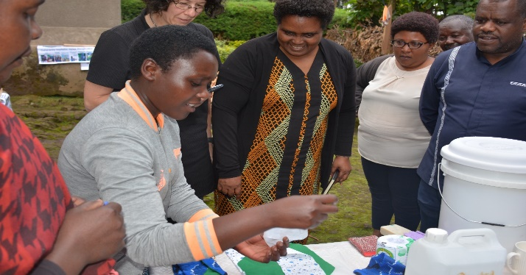

*Pictures that provide insights of youth endeavors and initiatives in the journey of promoting hygiene and sanitation in rural areas, under the sponsors from PH and its partners*

1. **Environmental Protection:** The issue of climate change as a large-scale concern intensifies the current and future vulnerabilities of young generations including youth. In this line, Hydraulic Program, involves and acknowledges the youth contribution in its various activities relate to environmental protection; to mitigate negative effects of climate fluctuations. Specifically, to bridge the gap between having information, action and behavioral change, despite raising awareness on the issue, youth participates in various activities including tree planting on buffer zones of water sources or on steep slope areas.

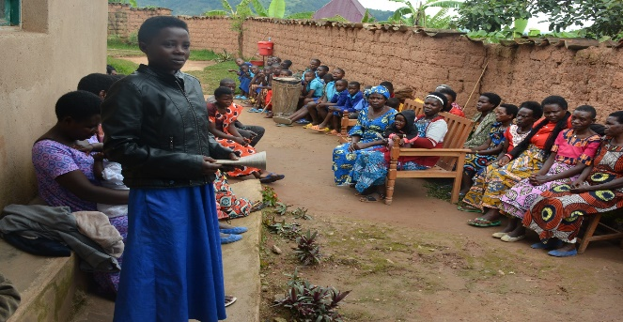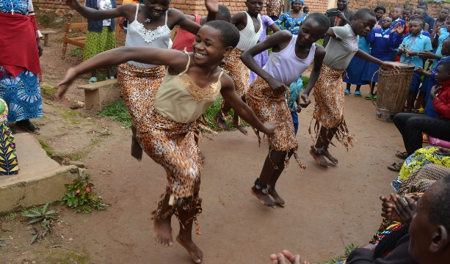

*Youth’ students’ contribution during environmental protection campaign organized by Hydraulic Program*

Done by Marie Yvonne INGABIRE

PH Coordinator